Dear Instructors,

It is my pleasure to invite you, your family & friends to the forthcoming UK ITF Bristol Banquet, which will follow the Grand Master Nicholls Seminar & Degree Grading on Saturday 7th April 2018.

The Seminar and Grading will be hosted by UK ITF so forms and payment need to be sent to UKITF directly by the instructor. Venue and deadlines for this will follow shortly once confirmed.

The Banquet will start at 7pm, at the Doubletree by Hilton Hotel, Woodlands Lane, Bradley Stoke, Bristol BS32 4JF.

I enclose with this letter further documentation to include: menu choices and directions to the venue. The evening will be formal dress, & is open to all consisting of a three course Banquet with presentations & speeches to be made after dinner.
The cost of this evening is £28 for three courses per person. There is also a child’s menu available for under 12’s at £18 for three courses. Please make cheques payable to ‘UK ITF Bristol’ and send to the address above. Payment can also be made via bank transfer to the following account details; UK ITF Bristol 30-98-29, 69100768. The closing date for Banquet orders is Wednesday 21st March 2018. Orders will not be processed without payment.

I look forward to sharing this very special event with you.

Yours Sincerely

Mrs Karen Lear IV Degree
On behalf of UK ITF Bristol

GRAND MASTER NICHOLLS BANQUET
MENU CHOICE & APPLICATION FORM
Saturday 7th April 2018 7.00-12.00pm
Doubletree by Hilton Hotel, Woodlands Lane, Bradley Stoke, Bristol BS32 4JF

Dear Students
Please list each person who will be attending the Grand Master Nicholls Banquet, to include yourself. (We will attempt to sit all people on this form at the same table) £28 for 3 courses.
- Name:________________________________
- Name:________________________________
- Name:________________________________
- Name:________________________________

Please tick one menu choice for each person attending the banquet.
MENU CHOICE | 1 | 2 | 3 | 4
Starter
Tomato and Basil Soup with Garlic Croutons
Italian cured Parma Ham, Galia Melon
Plum Tomato and Basil Quiche
Main Course
Oven roasted Chicken Breast wrapped in streaky bacon with thyme roasted potatoes
Pan Fried Hake Fillet, herb mash, green beans and mussels in white wine sauce
Spinach onion and Goats Cheese Tart, plum tomato and basil sauce
Dessert
Baked chocolate Cookie Cheesecake with chocolate sauce
Trio of chocolate torte with strawberry sauce
Exotic fruit salad, raspberry sorbet

Please Read and Sign
I would like to apply for a place on the above mentioned banquet
I have enclosed the following amount: £__________By: Cheque/Cash (Please make cheques payable to ‘UK ITF Bristol’)
I understand that a place will only be reserved when full payment has been received and cleared.
(Please state any allergies or dietary requirements)
Your Signature:__________________________________ Date:_____________________

GRAND MASTER NICHOLLS BANQUET
CHILDS MENU (UNDER 12)
Saturday 7th April 2018 7.00-12.00pm
Doubletree by Hilton Hotel, Woodlands Lane, Bradley Stoke, Bristol BS32 4JF

Dear Students
Please list each person who will be attending the Grand Master Nicholls Banquet, to include yourself. (We will attempt to sit all people on this form at the same table) £18 for 3 courses.
- Name:________________________________
- Name:________________________________
- Name:________________________________
- Name:________________________________

Please tick one menu choice for each person attending the banquet.
MENU CHOICE | 1 | 2 | 3 | 4
Starter
Heinz Tomato Soup
Sliced Honeydew Melon with berries
Main Course
Roasted chicken breast with potato mash, carrots and gravy
Fish Fingers with chips and baked beans
Tomato and vegetable pasta with cheddar cheese topping
Dessert
Chocolate fudge cake with chocolate sauce
Fruit salad with Vanilla ice cream

Please Read and Sign
I would like to apply for a place on the above mentioned banquet
I have enclosed the following amount: £__________By: Cheque/Cash (Please make cheques payable to ‘UKITF Bristol’)
I understand that a place will only be reserved when full payment has been received and cleared.
(Please state any allergies or dietary requirements)
Your Signature:__________________________________ Date:_____________________

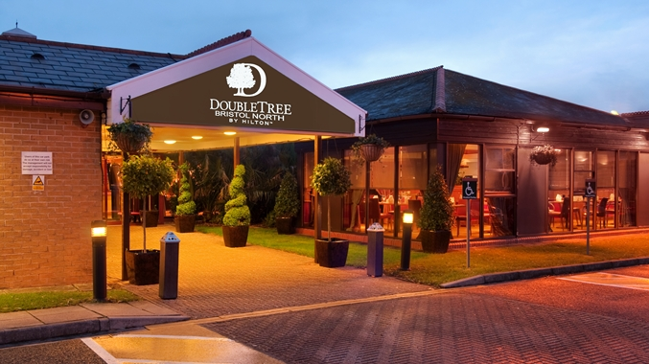
Doubletree by Hilton Hotel – Bristol North
Woodlands Lane
Bradley Stoke
Bristol
BS32 4JF

Tel: 01454 893438
Mon-Fri – 9am til 5pm.
Rooms are priced at £65 B&B for single or double occupancy.
(Please quote UKITF BRISTOL when booking your room for discounted rates).
The above rates are on a first come first served basis.
Car parking is free for all guests attending the event and staying overnight.

Directions by car
Exit Bristol Airport and take the A38 for city centre. At the Bedminster Bridge roundabout take the 3rd exit for the A38. Join the M32 then the M4. Leave the M4 at Junction 20 and join the M5. Exit the M5 at Junction 16. At the traffic lights, follow directions for Bradley Stoke. The hotel is visible on the left. At the roundabout take the 1st exit and then left, left and left again. This journey is 24km and takes 45 minutes.
To reach the hotel from M5 motorway, leave M5 at junction 16 and bear left onto slip road. At roundabout, travel onto the A38 Gloucester Road, sign posted for Bristol. At Aztec West round about, take 1st exit (hotel will be visible on left hand side). Turn left into Bradley Stoke Way and stay in left-hand lane at traffic lights. Take first left into Ashridge Road, the hotel is located immediately on the left hand side.
